Polarization Study

B. J Elash, A. E. Bourassa, L. A. Rieger, Seth?, Dan?, D. A. Degenstein

**Abstract:**

# **1 Introduction**

# **2 Model and Scenarios and Aerosol Sensitivity**

In order to compare the effect of polarization on the sensitivity to model to accurate computer polarized radiance models is required as well as suitable set of aerosol profiles for the retrieval. In this section the SASKTRAN model used for the analysis with be discussed and the aerosol scenarios used for the analysis.

## 2.1 SASKTRAN model

## 2.2 Aerosol Scenarios

The range of plausible aerosol profiles within the atmosphere are vast and cannot be completely covered due to the vast range of particle size distributions and possible consternations which affect their importance in radiative forcing. Furthermore, with the limb scatter technique the geometry of the measurement also can have a large effect on the sensitivity of the measurement to aerosol. To probe a large portion of this space a series of scenarios were derived.

To probe the aerosol space two profile and four particle size distribution were used. The two profiles are a background aerosol extinction profile typically during the volcanically quiet period starting in 1997, and the second profile is a representative volcanic profile after the Nabro eruption in 2012 with a higher sulfur injection from the eruption at approximately 20 km. Both profile can be observed in Figure 1. A log-normal particle size distribution was selected with two fine modes and one coarse mode which can be seen in Table 1. The aerosol profile could either completely consist of only one of the fine mode or a mix of 50% fine mode and 50% coarse mode. The fine modes are representation of two background aerosol particle size distributions and the coarse mode is a representation the effect of a volcanic eruption on the size of the aerosol droplets (Deshler et al, 2003).

To scan the entire geometry a range of Solar Zenith Angles (SZAs) and Solar Scattering Angles (SSA) were selected. The range of SZA are 15 o, 45 o, and 75o and SSA of 30 o, 60 o, 90 o, 120 o, 150 o, and 180o cover the a large portion of the possible geometries for limb scatter. An albedo of 0 and 1 were used to determine how ground reflectance effect aerosol sensitivity on polarization measurements. And the wavelengths chosen were 500, 750, 1000, 1250, 1500 nm to cover the effect of polarized measurements for wavelengths commonly used by instruments to achieve aerosol profiles from limb instruments (i.e. OSIRIS and SCHIAMACHY aerosol products used 750 nm TODO:ADD CITATIONS) and from work done by Rieger er al. (2014) has shown near infrared is needed to discern particle size from limb scatter neasurements.

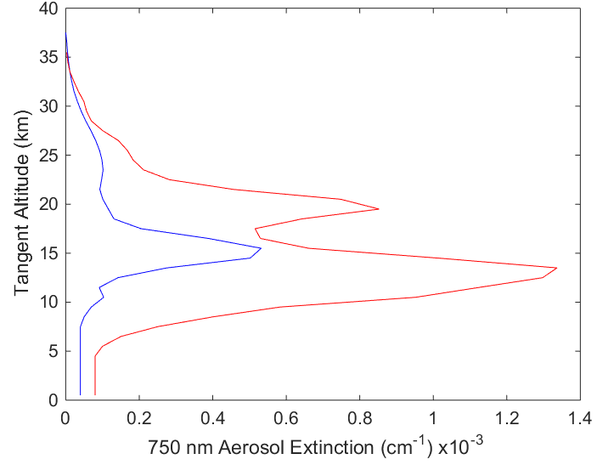

Figure 1: The two aerosol profiles used in this study. The blue is a background aerosol extinction levels, and the red curve is a representative aerosol profile after the Nabro eruption.

|  |  |  |  |  |  |
| --- | --- | --- | --- | --- | --- |
| Particle size distributions | Fine mode radius (µm) | Fine mode width | Coarse mode radius (µm) | Coarse mode width | Percent extinction coarse mode (%) |
| 1 | 0.04 | 1.8 | -- | -- | 0 |
| 2 | 0.12 | 1.25 | -- | -- | 0 |
| 3 | 0.04 | 1.8 | 0.30 | 1.15 | 50 |
| 4 | 0.12 | 1.25 | 0.30 | 1.15 | 50 |

Table 1: Different particle size distributions used to test the sensitivity of the aerosol retrieval.

# 3 Aerosol sensitivity to polarization

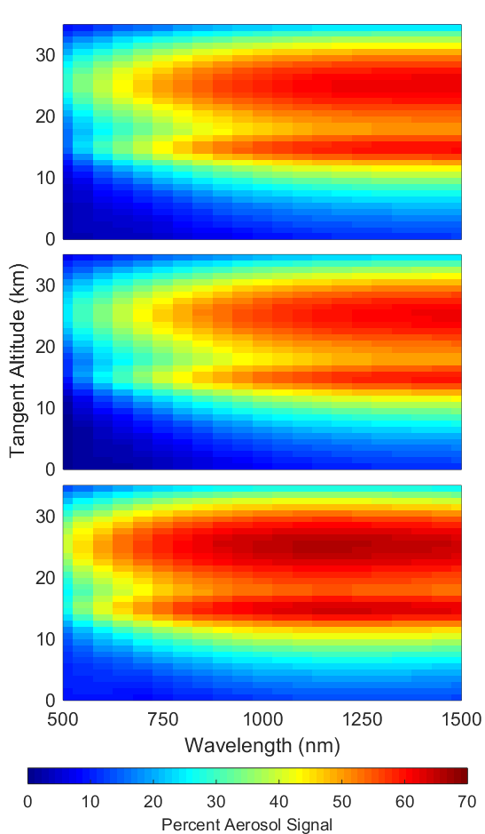

Figure 2: A computation of the percentage of aerosol radiance signal over the total radiance for a series of three polarizations. The top, middle, and bottom figures are the scaler, horizontal polarization, and vertical polarization respectively. The geometry for the simulation is set up with SZA of 45o and SSA of 60o with an Albedo of 0 and using the background aerosol profile.

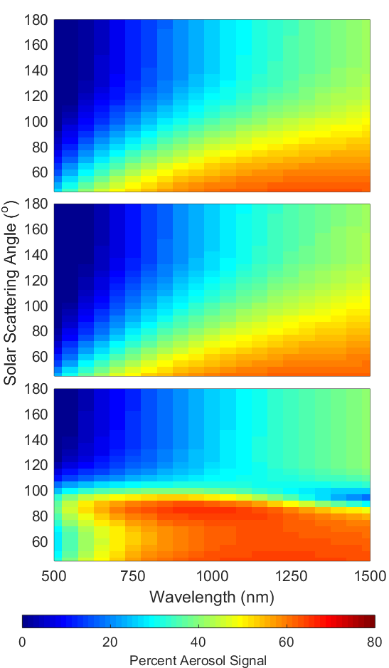

Figure 3: A computation of the percentage of aerosol radiance signal over the total radiance for a series of three polarizations. The top, middle, and bottom figures are the scaler, horizontal polarization, and vertical polarization respectively. The geometry for the simulation is set up with SZA of 60o at a tangent point of 15.5 km with an Albedo of 0 and using the background aerosol profile.

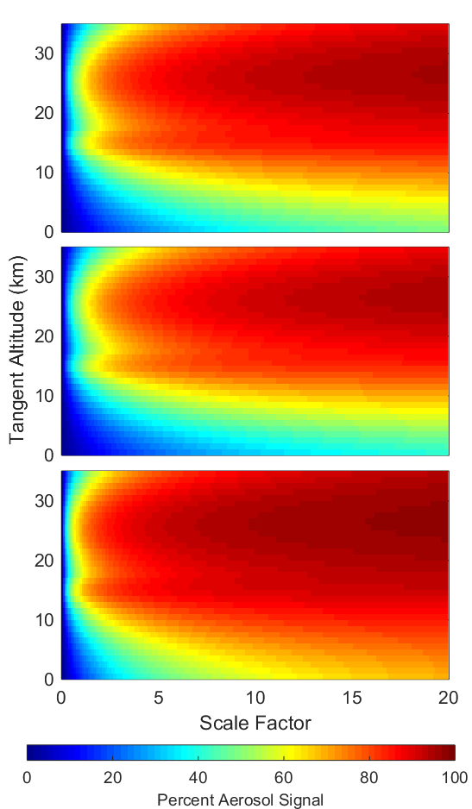

Figure 4: A computation of the percentage of aerosol radiance signal over the total radiance for a series of three polarizations. The top, middle, and bottom figures are the scaler, horizontal polarization, and vertical polarization respectively. The geometry for the simulation is set up with SZA of 45o and SSA of 60o with an Albedo of 0 and using the background aerosol profile.

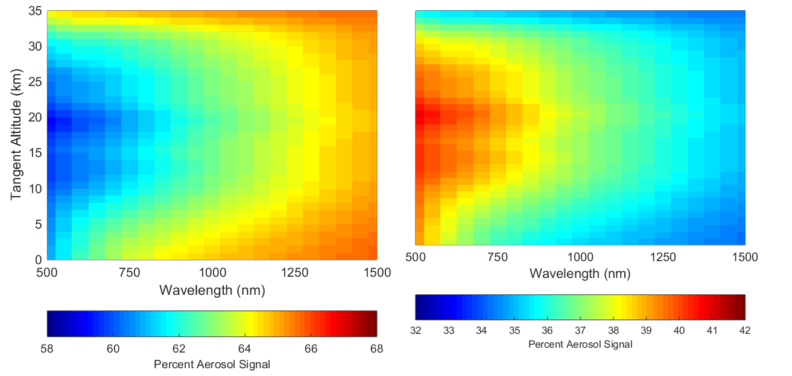

Figure 5: A percent of the linear polarized radiances to the scaler radiance, the left and right figures are the horizontal and vertical polarizations respectively. The radiances were calculated with a geometry of 45o SZA and 60o SSA with an albedo of 0 and using the background aerosol profile. Note that the scale for each plot are different.

# 4 Retrievals

## 4.1 Methodology

## 4.2 Retrievals

TO CREATE FIGURE

Figure 6: The retrieved aerosol profiles for each unique combination of geometry and aerosol profile are compared again the known original sates. The plot are separated into 16 cases. The four columns represent the four polarization used for the analysis and from left to right is the scaler radiance with the scaler SASKTRAN-HR model, the scalar radiance with the polarizations models, the horizontal polarization, and the vertical polarization. The rows represent the four particle size distributions from one to four from top to bottom as listed in Table 1.

## 4.3 Error analysis

TO CREATE FIGURE

Figure 7: Not sure have not been able to complete this yet. Will discuss in Email.

# **5. Conclusions**